NAME : NIYA DODIYA

FA2

ROLLNO : 2199

# Q1

class ArmstrongCheck:

def __init__(self, number):

self.number = number

self.checked = False # Used to ensure only one iteration happens

def __iter__(self):

return self

def __next__(self):

if not self.checked:

self.checked = True

digits = [int(d) for d in str(self.number)]

power = len(digits)

result = sum([d ** power for d in digits])

return result == self.number

else:

raise StopIteration

# User input

num = int(input("Enter a number: "))

# Create object and use iterator

checker = ArmstrongCheck(num)

for is_armstrong in checker:

if is_armstrong:

print(f"{num} is an Armstrong number.")

else:

print(f"{num} is not an Armstrong number.")

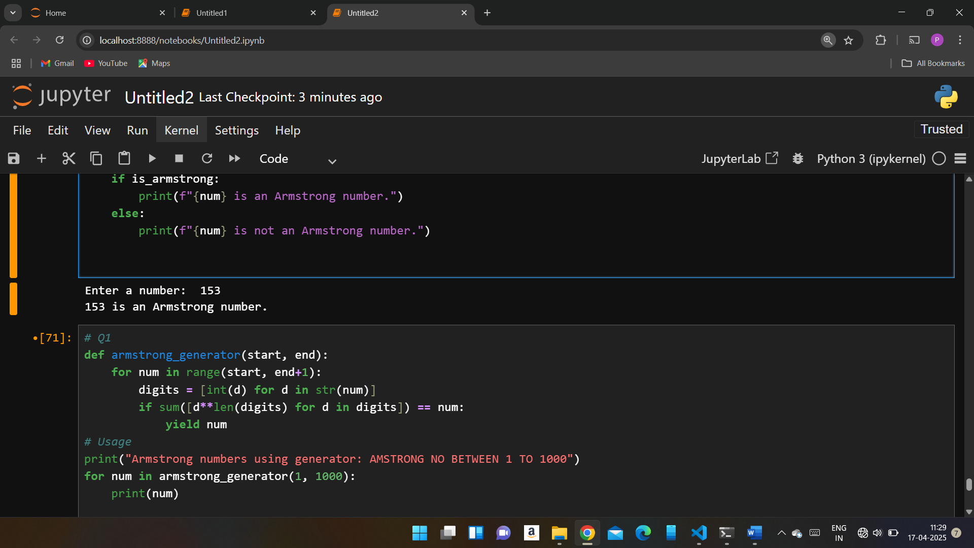

# Q2

def armstrong_generator(start, end):

for num in range(start, end+1):

digits = [int(d) for d in str(num)]

if sum([d**len(digits) for d in digits]) == num:

yield num

# Usage

print("Armstrong numbers using generator: AMSTRONG NO BETWEEN 1 TO 1000")

for num in armstrong_generator(1, 1000):

print(num)

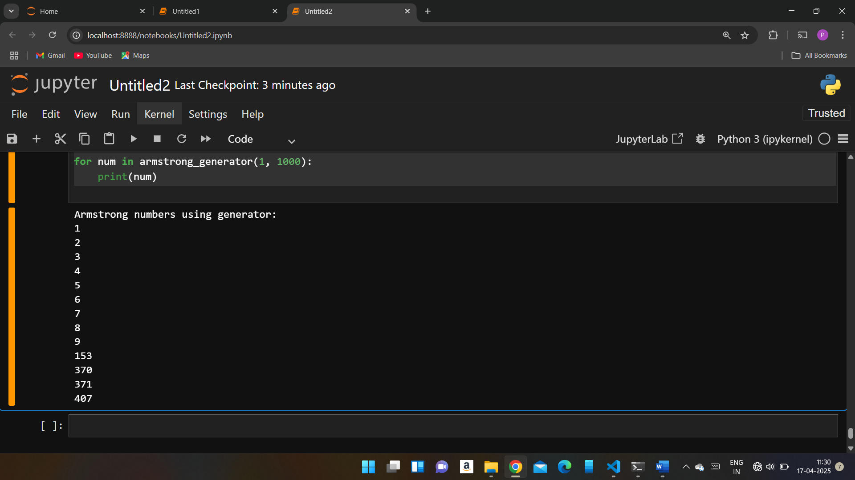

import pandas as pd

import numpy as np

readdata = pd.read_csv('p1.csv')

readdata

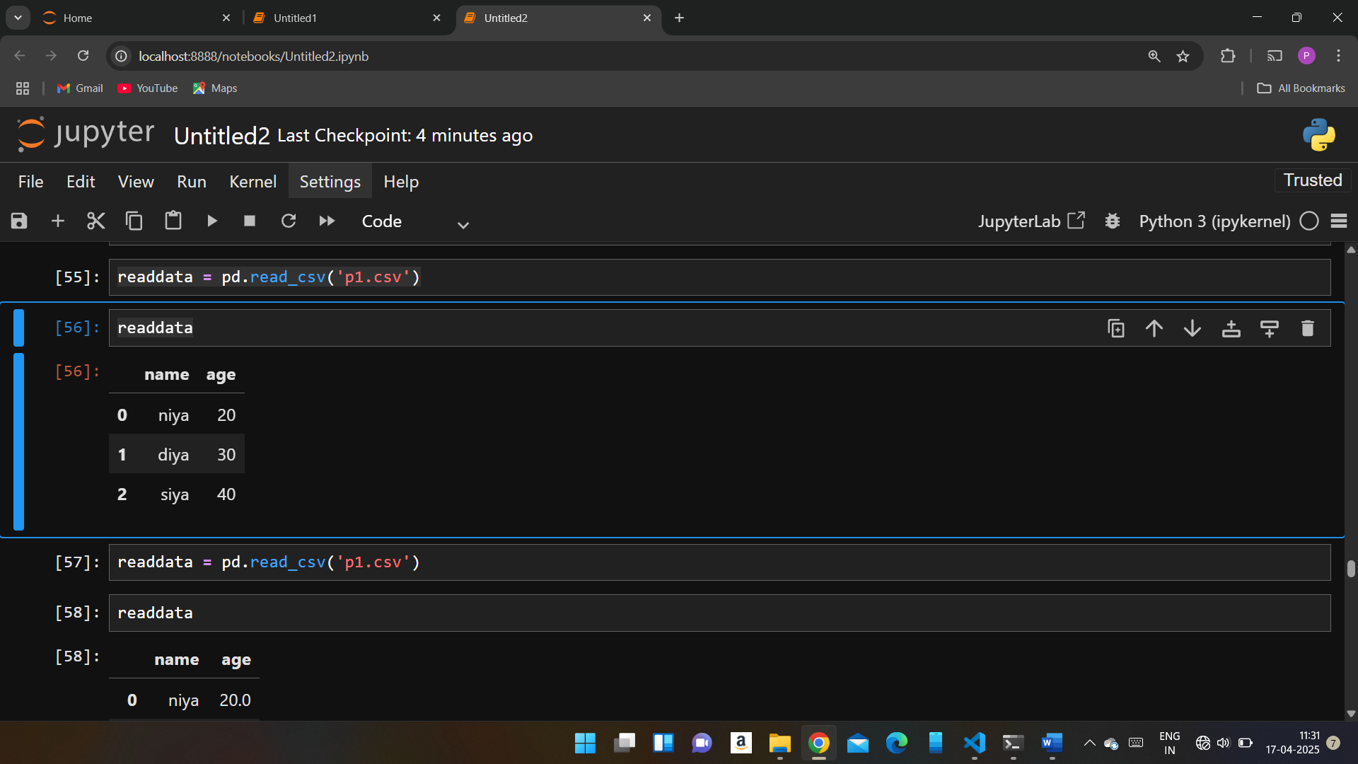

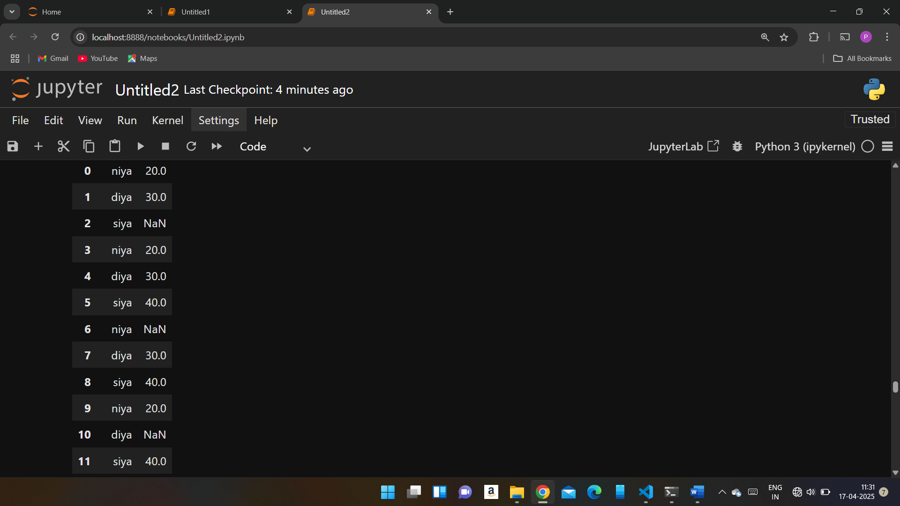

readdata['age']=readdata['age'].fillna(0)

readdata

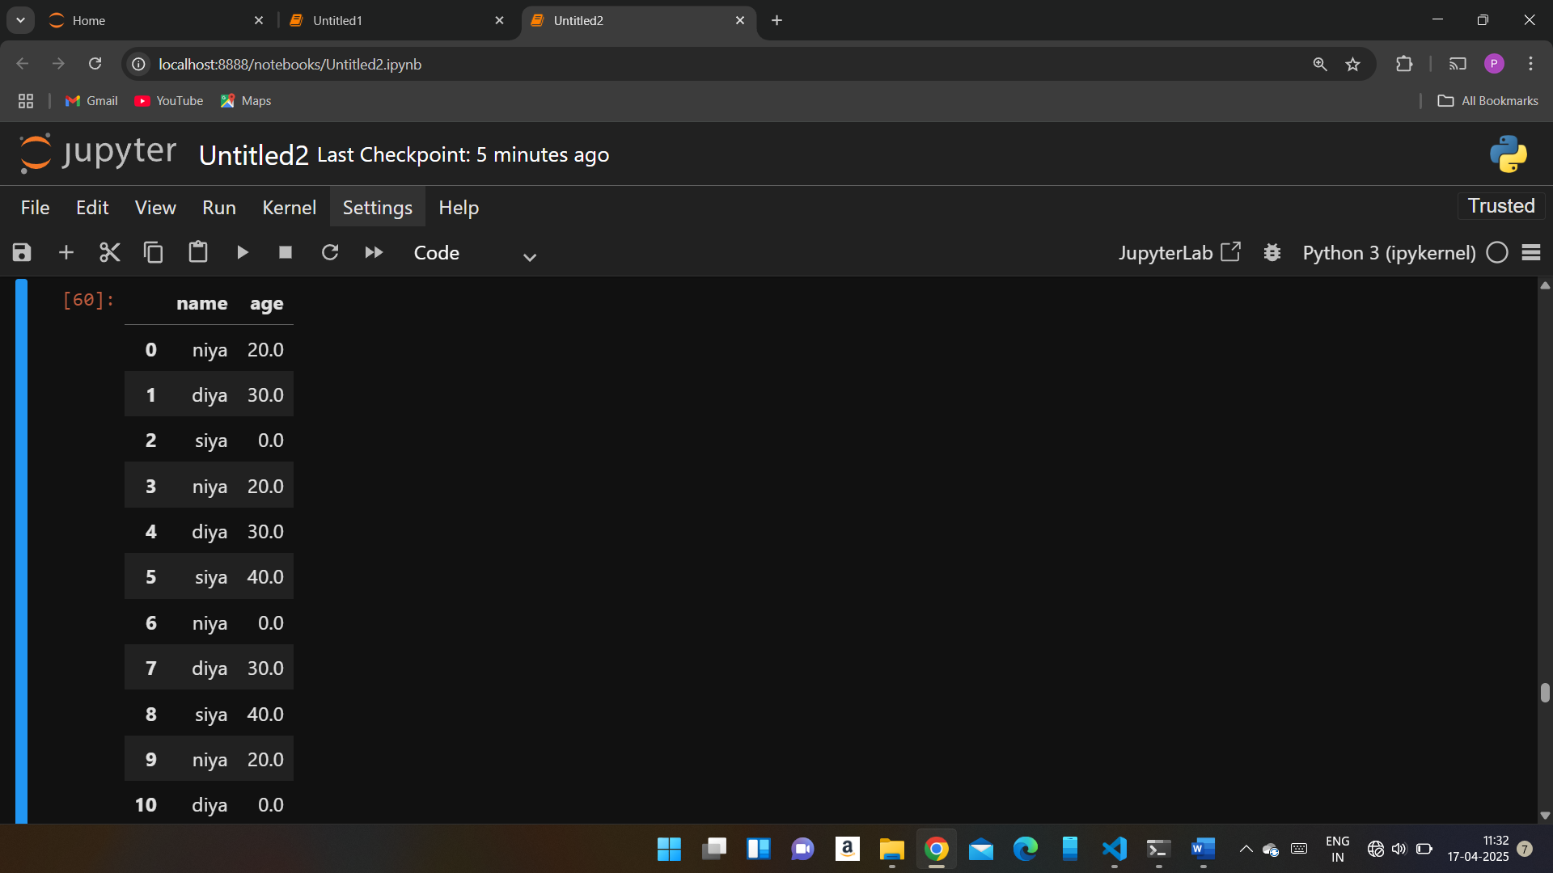

# ?Q4

data=[['name','age'],['niya',20],['diya',30],['siya',40]]

with open("p1.csv","w",newline='')as file:

read = csv.writer(file)

read.writerows(data)

with open("p1.csv","r")as file:

read = csv.reader(file)

for row in read:

print(row)

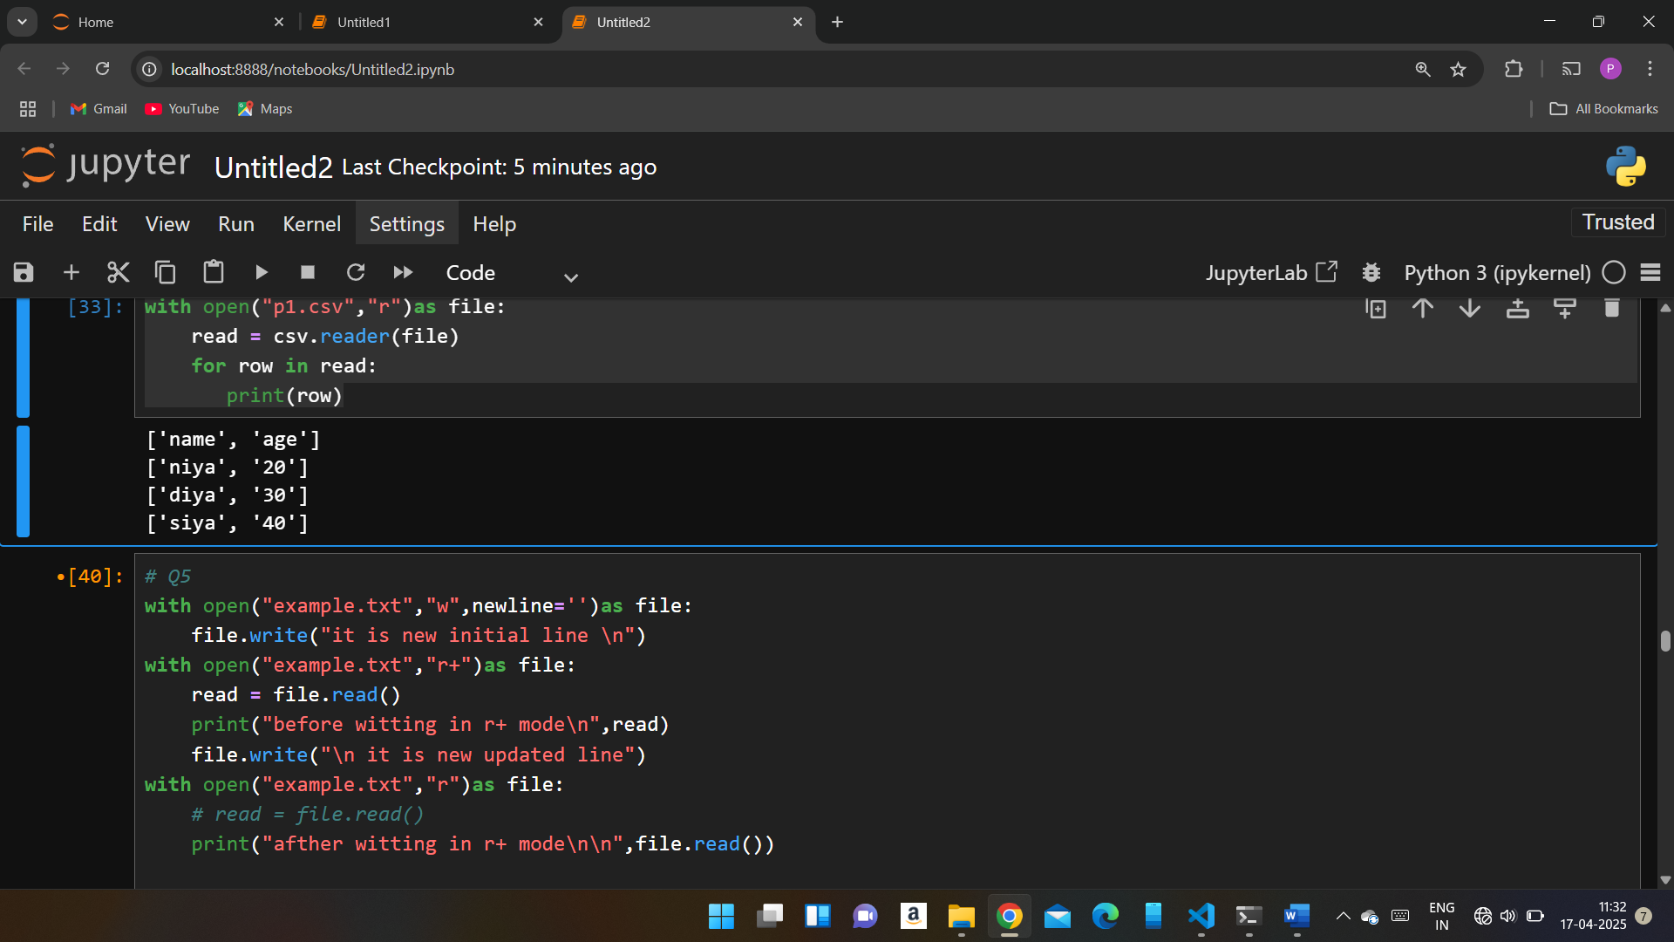

# Q5

with open("example.txt","w",newline='')as file:

file.write("it is new initial line \n")

with open("example.txt","r+")as file:

read = file.read()

print("before witting in r+ mode\n",read)

file.write("\n it is new updated line")

with open("example.txt","r")as file:

# read = file.read()

print("afther witting in r+ mode\n\n",file.read())

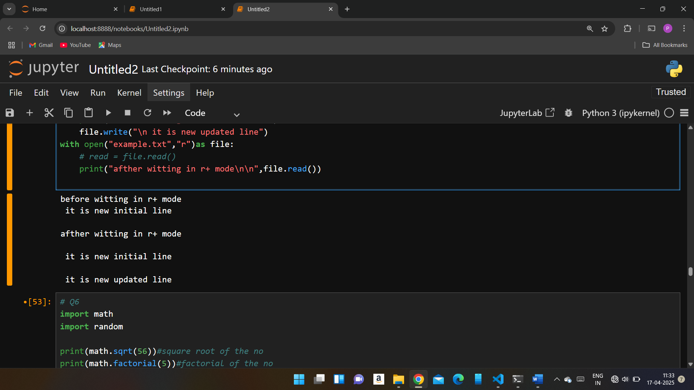

# Q6

import math

import random

print(math.sqrt(56))#square root of the no

print(math.factorial(5))#factorial of the no

print(abs(-16))#absalute value of the no

list = [1,2,3,4,5,6,7,8,9,10]

print(random.randint(1,5))#chose random integer b/w 1 to 4

print(random.random())#chose random integer b/w 1 to 4

print(random.choice(list))#chose random integer b/w 1 to 4

random.shuffle(list)

print(list)#first shuffle

random.shuffle(list)

print(list)#second shuffle

